**Communication Management Plan**

**D7 Auto Service Center**

**D7 Auto Service Center**

**C.M. De Los Reyes Avenue,** **Manggahan,**

**General Trias, 4107 Cavite, Philippines**

**Table of Contents**

Introduction 3

Communications Management Approach 3

Communications Management Constraints 4

Stakeholder Communication Requirements 5

Roles 6

Project Team Directory 7

Communication Methods and Technologies 8

Communications Matrix 10

Communication Flowchart 11

Guidelines for Meetings 11

Communication Standards 13

Communication Escalation Process 14

Glossary of Communication Terminology 15

# Introduction

The D7 Auto Service Center Web-app project considers the Communications Management Plan as a crucial element since it specifies the communication strategy and protocols for the stakeholders and project team. The plan outlines the following:

* The project information details that will be communicated are outlined in the plan; these may include project updates, progress reports, risks, and challenges. In addition, it outlines the format and particular informative components, such as whether the information will be communicated verbally or in written form.
* To ensure that all stakeholders are informed promptly, the plan delineates the communication methods that will be utilized, including meetings, emails, and other means of communication.
* The plan sets up a schedule for project communications, encompassing both formal and informal means, to ensure that stakeholders are constantly updated.
* The plan specifies the communication-related duties and obligations of team members and stakeholders, clarifying who is responsible for sharing project information.
* The plan describes the distinct communication needs of each stakeholder and the approach to meet those needs, including accessibility and language requirements.
* The plan defines the procedures for sharing sensitive or confidential information and designates who has the authority to release such information.
* To ensure consistency in the communication process throughout the project, the plan defines a process for managing any changes to communication or the communication process itself. This includes procedures for proposing, reviewing, and approving changes to keep all stakeholders informed.
* The plan lays out a process for managing alterations in communication or the communication process, encompassing the proposal, review, and approval of changes. This guarantees that all stakeholders are informed of any changes and that the communication process is consistent throughout the project.
* The plan specifies the process of communication within the project, including how information is disseminated among team members, stakeholders, and other project partners. This ensures that all stakeholders are informed, and that information is exchanged promptly and efficiently.
* The plan recognizes any internal or external factors that may impact project communications, such as legal or regulatory obligations, and specifies how these constraints will be managed. It outlines the procedures and measures to address any limitations that may hinder effective communication during the project. This ensures that communication is maintained within the legal and regulatory frameworks, and that project objectives are met.
* The plan specifies the mandatory templates, formats, or documents for transmitting project information, like meeting minutes or progress reports. This guarantees that all stakeholders receive consistent and precise information.
* The plan incorporates a protocol for escalating and resolving any communication-related conflicts or challenges that may arise during the project. This protocol helps to ensure that any communication-based issues are dealt with and resolved promptly, thus ensuring the smooth flow of the project.

Overall, the communication management plan is a crucial tool to ensure that all stakeholders are informed, and that communication of the team is effective and efficient throughout the D7 Auto Service Center Web-app Project.

# Communications Management Approach

Communication will be very pivotal in the project’s phases, which is why the approach that will be utilized for this project is thought of by the team to be a combination of proactive and reactive strategies, while it also takes communication through online and onsite mediums.

Proactive by means of having regular project status meetings that will be set to have the members and the project stakeholder be informed of the deliverables that are being made, while it also informs the team of what needs to be accomplished. Through this approach, the team communication will flow through the project’s phases which will be comprised of the updates with regards to the deliverables, the progress reports, the issues that rose which could cause a bottleneck in the process and may require contingency.

Reactive strategy will also be implemented in the process of the project as it is also required to have feedbacks as a means of understanding and resolving the communication-based conflicts, misunderstandings, and/or conflicts that could hinder the project between the sides of either the client or the development team.

The team will also be conducting meetings with the project manager through onsite and online premises, depending on which medium is best used in situations. This approach will also seek to choose which mode will be most convenient.

# Communications Management Constraints

The constraints that the communications management will have will be dependent on following limitations of, but not, limited to the following:

1. **Limited budget to travel onsite:** The project will have limitations in travelling onsite to the client to report pertinent information for the project.
2. **Limited access stakeholders:** Due to the stakeholder’s limitations due to the work schedule, this will also be a constraint if the stakeholder is unable to meet with the development team, is in a remote location, or is unavailable for certain reasons.
3. **Limited availability of development team:** The team members will also have limited schedule availability, due to prior commitments, and/or other responsibilities which makes their availability limited.

# Stakeholder Communication Requirements

The D7 Auto Service Center Web-app project relies heavily on Stakeholder Communication Requirements, which outline the communication needs of all stakeholders involved in the project. The effective implementation of these requirements is crucial for the timely completion of the project within budget and to the satisfaction of all stakeholders. The project team can ensure that stakeholders' expectations are met by addressing their specific communication requirements, thereby building trust, and promoting collaboration.

The Communication Management Plan for the D7 Auto Service Center Web-app project contains information regarding the stakeholders' communication needs and how they will be met during the project's lifecycle. This includes the Stakeholder Communication Requirements, which outline the following:

1. **Regular project updates**: It is essential to keep all stakeholders informed of the project's progress, including any issues or risks that may arise.
2. **Clear and concise communication**: To ensure stakeholders understand the message, all project-related information should be communicated in a clear and concise manner.
3. **Accessibility:** Communication should be accessible to all stakeholders, considering any language or accessibility needs.
4. **Timely communication**: Information should be communicated in a timely manner, ensuring that stakeholders are informed as soon as possible.
5. **Confidentiality: Any sensitive or confidential information should be communicated only to the necessary stakeholders and handled securely.**
6. **Customized communication: Communication should be tailored to each stakeholder's specific needs, considering their level of involvement in the project and their role.**
7. **Two-way communication**: Communication should be a two-way process, allowing stakeholders to provide feedback and ask questions.
8. **Feedback mechanisms**: A mechanism for stakeholders to provide feedback on the communication process should be in place to ensure that communication is effective and meets their needs.

# Roles

|  |  |
| --- | --- |
| **Roles** | **Responsibilities** |
| Project Sponsor | The project sponsor is responsible for approving all changes to the budget/funding allocations, approving all changes to the schedule baseline, and approving any changes in project scope, as well as signing the project charter for the D7 Auto Service Center web-app project. |
| Project Manager | The project manager is responsible for planning, executing, and closing the D7 Auto service center web-app project. They lead the project team and ensure that the system is completed within the required quality standards, on time, and within budget. |
| Team Leader | The Team Leader is responsible for giving direction and guidance to team members to complete the D7 Auto Service Center web-app project within the given constraints. This includes delegating tasks, monitoring progress, providing feedback and support, and ensuring that all team members are working collaboratively towards achieving project objectives. |
| Team Developer | The team developer collaborates closely with the team leader to ensure the project is completed quickly and efficiently. They are responsible for the design, coding, testing, and implementation of the project, ensuring that it meets the necessary requirements and is of high quality. |
| Team Developer Support | The team developer support works in collaboration with the team's developer and assists them in carrying out various tasks related to designing, coding, testing, and implementing the project. They provide additional support to ensure that the project is completed successfully and on time. |
| Team Secretary/Stakeholder | The team secretary/stakeholder coordinates communication and documentation, organizing meetings, managing schedules, and ensuring that participants and roles are defined for the business case and throughout the project's life. |
| Team Secretary Support | The team secretary support role involves working in close collaboration with the team's secretary to provide administrative assistance and support in coordinating team activities. This may include scheduling meetings, organizing documentation, and assisting with communication and coordination to ensure the project's smooth operation. |

# Project Team Directory

The following table presents contact information for all persons identified in this communications management plan. The email addresses and phone numbers in this table will be used to communicate with these people.

|  |  |  |
| --- | --- | --- |
| **Name** | **Role** | **Email** |
| Anne Sydney R. Simpelo | Project Sponsor | d7autoservicecenter@gmail.com |
| Andre O. Viernes | Project Manager | aoviernes@student.apc.edu.ph |
| Dan Michael C. Alfaras | Project Leader | dcalfaras@student.apc.edu.ph |
| Alyssa L. Garcia | Web Developer | algarcia@student.apc.edu.ph |
| Francesca Erin R. Camino | Project Secretary | frcamino@student.apc.edu.ph |
| John Zenon P. Coquia | Team Developer Support | jpcoquia@student.apc.edu.ph |
| Darrell Royce A. Lazala | Team Secretary Support | dalazala@student.apc.edu.ph |

# Communication Methods and Technologies

To successfully communicate with all stakeholders involved in the D7 Auto Service Center Web-app project, it is crucial to have a comprehensive knowledge of the communication methods and technologies to be used. It is necessary to assess the strengths and weaknesses of each communication method and technology to ensure that stakeholders receive the information they require promptly and effectively. This involves identifying the appropriate ways to provide updates, progress reports, risks, issues, and other pertinent details related to the project.

To identify the most suitable communication methods and technologies for the D7 Auto Service Center web-app project, it is important to consider numerous factors, such as:

* The technical proficiency level of stakeholders: Simple communication methods like email and telephone may be preferable for stakeholders not particularly familiar with technology.
* The nature of the information being communicated: When sensitive or confidential information is involved, secure methods such as encryption and password-protected portals may be required.
* The project's budget and available resources: The chosen communication methods and technologies must be financially feasible and sustainable within the project's allocated budget and available resources.

# Communications Matrix

The following table identifies the communications requirements for this project.

Table Communications Matrix Table

|  |  |  |  |  |  |  |
| --- | --- | --- | --- | --- | --- | --- |
| Channel | From | To | Type | Frequency | Format Used | Delivery media |
| Project Planning | Project Manager | Stakeholders | Meeting | Once before the start of the project | Formal | Onsite and social media |
| Release Planning | Project Manager, Project Team | Stakeholders | Meeting | Once before the start of the project. Updated when necessary | Formal | Onsite and social media |
| Sprint Planning | Project Manager | Project Team | Meeting | Twice a week or as needed | Informal | Microsoft Teams and social media |
| Management Processes | Project Manager, Project Team | Stakeholders | Deliverable | Once before the start of the project. Updated when necessary | Written Document | Google space (Gmail) |
| Product Backlog | Project Manager | Project Team | Deliverable | Twice a week or as needed | Written Document | Microsoft Teams, GitHub |
| Project Update | Project Manager | Project Team | Meeting | Twice a week or as needed | Informal | Microsoft Teams and social media |

# Communication Flowchart

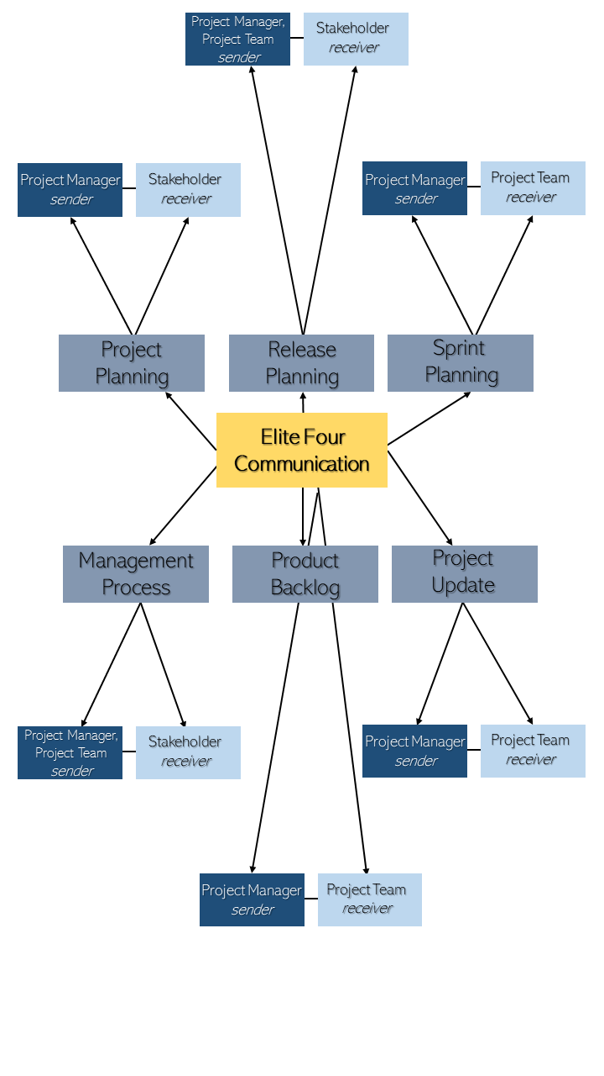

# Guidelines for Meetings

Meetings are an essential aspect of efficient communication within any project, and the D7 Auto Service Center web-app project is no different. To ensure the effectiveness, productivity, and efficiency of meetings, it is crucial to establish well-defined guidelines that specify the purpose of the meetings, the roles and responsibilities of attendees, and the procedures that will be followed during the meetings.

Establishing clear guidelines for meetings can improve the effectiveness of communication among project team members and stakeholders. These guidelines enable participants to better prepare for meetings and engage in discussions more effectively. Furthermore, the project manager can ensure that meetings are conducted in an organized and consistent manner, which can prevent confusion and misunderstandings.

The following are the meeting guidelines that should be observed for the D7 Auto Service Center web-app project to ensure that the meetings are productive, efficient, and effective:

* **Purpose:** Meetings are an important part of the project, and they should be clearly defined and communicated to all attendees in advance.
* **Attendees:** The roles and responsibilities of attendees should be clearly defined and communicated in advance. Only attendees necessary for the meeting should be invited.
* **Agenda:** A clear, concise agenda should be developed and distributed to all attendees before the meeting.
* **Procedures**: Procedures for conducting the meeting should be established and communicated in advance, including guidelines for discussion, decision-making, and action items.
* **Time:** The duration of the meeting should be limited to the time necessary to achieve the meeting's objectives, and the meeting should start and end on time.
* **Follow-up**: Follow-up actions and decisions should be clearly documented and communicated to all attendees after the meeting.
* **Technology:** The technology used for meetings should be accessible to all attendees. This may involve the use of video conferencing technology, such as Microsoft Teams.
* **Evaluation:** Regular evaluation of meetings is necessary to ensure that they are productive and that attendees are satisfied with the outcomes. Any issues that arise during meetings should be addressed promptly, and appropriate measures taken to improve and enhance future meetings' effectiveness.

# Communication Standards

The appropriate and best communication standards for the D7 Auto Service Center Web-app project are the following:

* **Standardized Template**: Creating and utilizing standardized templates for project communications, such as status reports, meeting agendas, and meeting minutes, can guarantee that the information shared is consistent and clear.
* **File Naming Convention:** Establishing a consistent naming convention for documents and files that are shared within a project can make it easier to retrieve and organize information.
* **Collaboration Tool:** The use of a standardized platform such as SharePoint, Open project software, or GitHub for project communication can enhance accessibility to information and promote collaboration among project team members and stakeholders.
* **Video Meetings: Use of Video conferencing tools like Microsoft teams can be useful for team members and stakeholders located at distinct locations.**
* **Communication protocols:** Establishing a standardized communication protocol for sensitive or confidential information, which outlines who is authorized to share it and how it should be shared, can help ensure the security and confidentiality of the data.

# Communication Escalation Process

The appropriate and optimal communication escalation process for the D7 Auto Service Center Web-app project would consist of the following:

1. Determining the problem:

* Any communication or issues related to the project should be first brought to the attention of the Team Developer Support.
* The Team Developer Support will assess the situation and try to resolve it themselves or escalate the issue to the next level if necessary.

1. Address the problem within the team:

* If the Team Developer Support is unable to resolve the issue, they will escalate it to the Team Leader.
* The Team Leader will review the issue and try to find a solution. If they are unable to do so, they will escalate the issue to the next level.

1. Involve the Project Manager:

* If the issue is not resolved by the Team Leader, it will be escalated to the Project Manager.
* The Project Manager will assess the situation and take appropriate action to resolve the issue. If they are unable to do so, they will escalate the issue to the next level.

1. Escalate to Project Sponsor:

* If the issue is still not resolved, it will be escalated to the Project Sponsor.
* The Project Sponsor will review the issue and take appropriate action to resolve it. They have the final authority to make decisions related to budget/funding allocations, schedule baseline changes, and project scope changes.

This communication escalation process ensures that issues related to the project are addressed in a timely and efficient manner, and that the appropriate level of authority is involved in making decisions related to the project.

# Glossary of Communication Terminology

|  |  |
| --- | --- |
| Term | Definition |
| Communications Management Plan | A plan that outlines the communication strategy and protocols for stakeholders and the project team. |
| Communication Methods | The methods used to communicate project information, including meetings, emails, and other means of communication. |
| Stakeholder | An individual that has an interest in a project, program, or organization. They can be both internal or external to the organization and can be affected by or have an effect on the project's or organization's actions, decisions, and outcomes. |
| Communication Flowchart | A visual representation that illustrates how information is communicated and moves throughout a project. |
| Communication Escalation Process | A process for resolving conflicts or issues related to communication. |
| Communication Standards | A communication standard is a set of guidelines or rules that define the methods, channels, formats, and protocols for exchanging information and ideas among individuals or groups within a project or organization. |
| Communication Constraints | A communication constraint refers to any factor that limits or affects the effectiveness of project communications. |
| Communication Approaches | A communication approach refers to the specific methods and strategies used to convey information and messages to the project stakeholders. |

Sponsor Acceptance

Approved by the Project Sponsor:

Date: ￼

Anne Sydney R. Simpelo

D7 Auto Service Center Owner

This free Project Communications Management Plan Template is brought to you by [www.ProjectManagementDocs.com](http://www.ProjectManagementDocs.com)